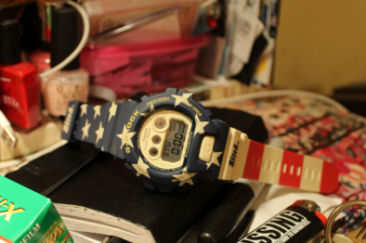

G-SHOCK AND ALIFE CHARGE UP FOR ANOTHER COLLABORATION
NYC Cultural Brand and Watch Giant Prep Second Union For Fall Release

CASIO G-SHOCK and ALIFE reignite their partnership for a limited edition timepiece. The balance between New York City Lifestyle, craftsmanship and design fuse together to create one of the most anticipated products of the Fall season.

The GDX6900AL-2 timepiece – designed with precision- is adorned with a patriarchal stars and stripes color scheme - inspired by American artist, Jasper Johns and his acclaimed flag paintings of the 1950s. Instead of using the traditional illuminating red, white and blue color scheme, the collaborative model portrays a muted version of the color palette. The new design simulates the technique Johns used throughout his career to enhance the vintage effects of his paintings.

“This design came about from the idea of representing where you are from. ALIFE is and has always been a very New York centric brand. For our newest project with G-SHOCK we decided that since this was a global product, let’s represent the country rather than the city we reside in”. - Founding father of ALIFE, Rob Jest

In true G-SHOCK form, there is always a duality of distinctive design and technological support in all time pieces. The GDX6900AL-2 features Shock Resistance, 200M Water Resistance, Auto LED (Super Illuminator). Flash Alert, 5 Daily Alarms, World Time (31 Time Zones / 48 Cities + UTC), Multi-Home Time Function, 1/100th Sec. Stopwatch (24HR), 1/10th Sec. Countdown Timer (24Hr), 12/24 HR Format, Mute Function and 10 Year Battery.

The product release will be accompanied by a video directed by young New York native, Sophie Day - former ALIFE team member and avid photographer and videographer. The short film highlights the timepiece as it leads a group of the city’s ‘Post Millennial’ youth, the individuals who have emerged at the tail end of the millennial boom. Centering a perspective on their stories and their perseverance to survive and succeed in the thriving metropolis, the completely unscripted video reveals the life of young individuals who will grow into the city’s next generation of creative catalysts and culture changers.

###

About ALIFE
Founded in 1999, ALIFE is a New York City-based, multitasking, multi-faceted lifestyle driven company. It is focused on art and creativity with a strong penchant for originality. ALIFE is well known for its branded apparel and footwear lines, curatorial work, creative direction and production of editorial content for books and magazines, art shows, retail concepts, top-tier collaborations, and live music events. ALIFE's mission is to showcase, elevate and perpetuate the downtown culture from which it is born while speaking to an international audience that is as close as down the block and as far as across the globe. www.alifenewyork.com

